**University of the Punjab**

**Gujranwala Campus**

**Department of Information Technology**



**Subject : Computer Vision**

**Prepared by :**

BIT21245 : Alisha Saif

BIT21235 : Noor Basharat

BIT21214 : Esha Aslam

**Submitted to:**

Mam Fouqia Zafeer

**Project :**

**Plant Disease Detection Using Deep Learning**

**Abstract**

Plant diseases can significantly affect crop yield and quality, leading to severe economic losses. Traditional disease detection methods rely on human expertise, which can be time-consuming and prone to errors. This project presents a deep learning-based approach for plant disease detection using Convolutional Neural Networks (CNNs). The model is trained on a dataset consisting of images of healthy and diseased plants. The system aims to automate and enhance the accuracy of disease detection, providing farmers with a reliable tool for monitoring plant health.

**Introduction**

Plant health is a crucial factor in agricultural productivity. Various plant diseases, such as early blight and late blight in potatoes, can cause significant crop damage if not detected early. The advent of deep learning and computer vision offers an opportunity to automate the identification of plant diseases using image classification techniques. This project utilizes a dataset containing images categorized into healthy and diseased plants and applies a CNN model to classify them effectively.

**Dataset Description**

The dataset used in this project is derived from the PlantVillage dataset and consists of three categories:

1. **Healthy Plants** - 1000 images
2. **Early Blight** - 1000 images
3. **Late Blight** - 1000 images

These images are preprocessed and fed into the CNN model for training and evaluation.

**Methodology**

1. **Data Preprocessing**
   * Image resizing and normalization
   * Data augmentation techniques to enhance model robustness
2. **Model Architecture**
   * Convolutional Neural Network (CNN)
   * Multiple convolutional layers followed by pooling layers
   * Fully connected layers for classification
3. **Training and Evaluation**
   * The model is trained on the dataset using GPU acceleration
   * Performance is evaluated using accuracy, precision, and recall metrics

**Results and Discussion**

The trained CNN model achieves high accuracy in detecting plant diseases. The system can classify images into healthy or diseased categories effectively. The use of deep learning provides a scalable and efficient method for plant disease identification compared to traditional methods.  
  
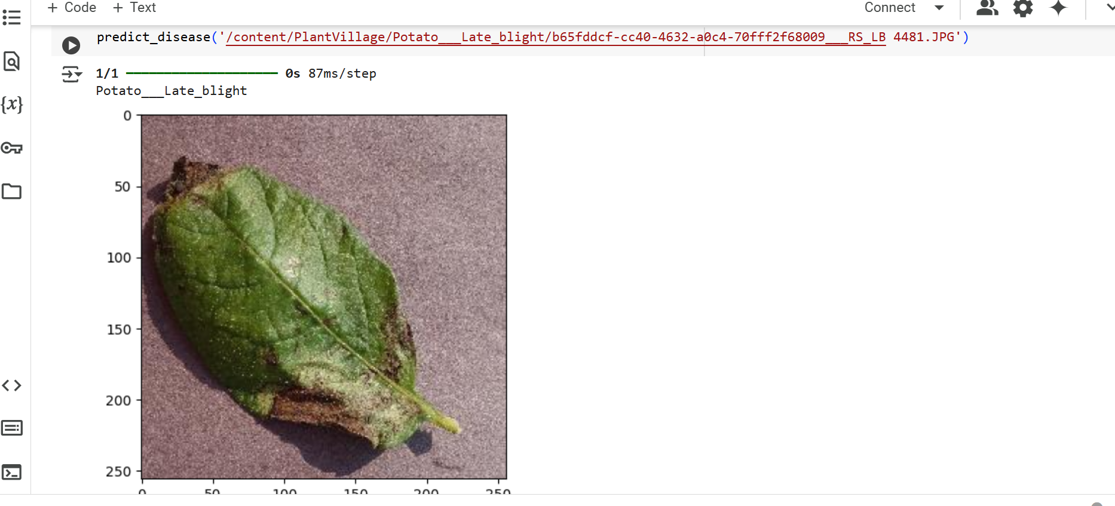  
  
  
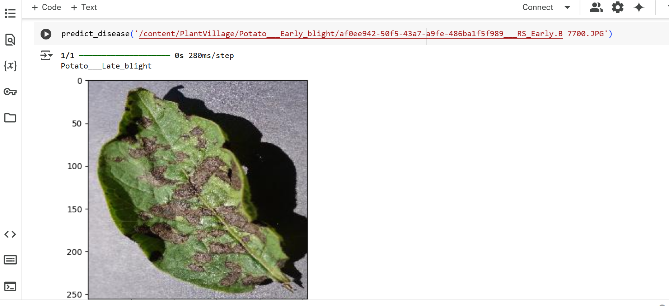

**Conclusion**

This project demonstrates the effectiveness of deep learning for plant disease detection. By utilizing a CNN model, the system automates the classification of plant diseases, enabling early diagnosis and better crop management. Future improvements could include integrating this model into a mobile application for real-time disease detection in the field.

**References**

* Kaggle PlantVillage Dataset
* Research papers on deep learning in agriculture
* PyTorch documentation